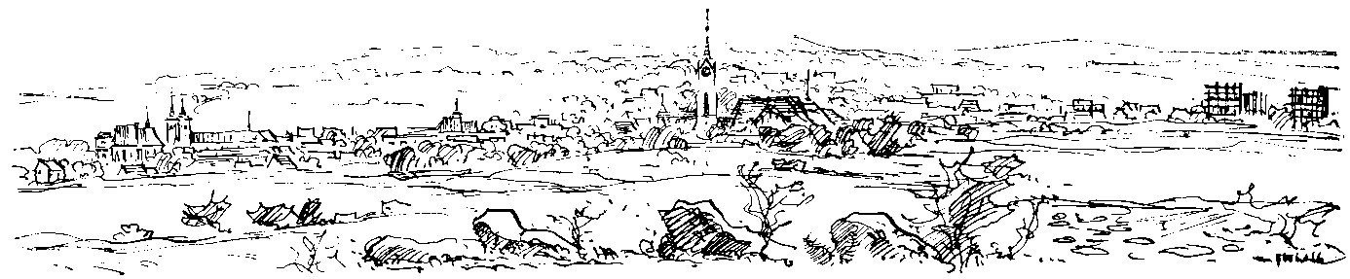
28th international competition in Rhythmic Gymnastics

MILEVSKO CUP

9. 3. 2019

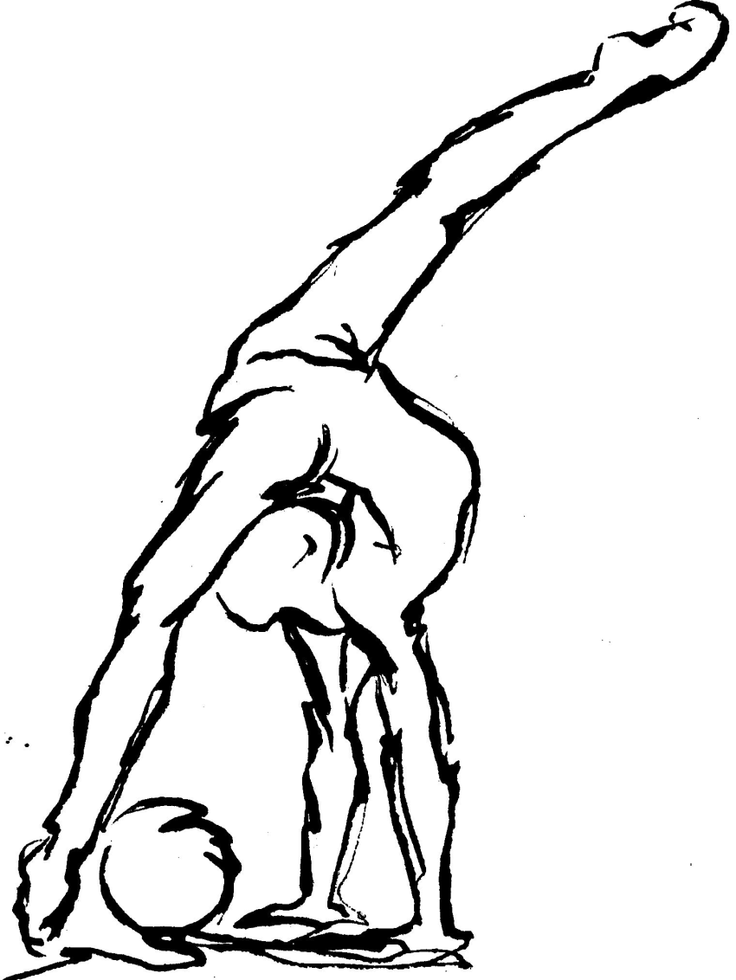
CZECH REPUBLIC

MILEVSKO CUP

9. 3. 2019

Dear sport friends,
We have the pleasure to invite you to participate to this 28th year of international competition in rhythmic gymnastics called Milevsko cup, which is organized by RG PROACTIVE Milevsko. This competition hold 9th March, 2019 in sports hall at Milevsko, street J. A. Komenského 1034, Czech Republic.
Hope to see you in Milevsko

Organizer | RG PROACTIVE Milevsko
Date | 9th March, 2019
Location | Sports hall, J.A. Komenského 1034, Milevsko, Czech Republic
Schedule | Friday 8. 3. 2019  17:00-20:00 – arrival of delegations, training  Saturday 9. 3. 2019  7:45 – presentation of all competitors  8:00 – technical meeting for the judges, trainers and organizers  9:00 – open the competition  19:00 – closing ceremony  20:00 - banquet
Size of the delegation | 1 judge!  5 gymnasts  1 coach
Registration | Must be till 20. 02. 2019!!  Send application form on email: hanka.kutiska@seznam.cz
Entry fees | 25 euro per each gymnast
Music | CD player
Accommodation and food | In the hotel next to sports hall = 25 EURO per person /day  -with breakfast and dinner
Contact | Kutišová Hana  + 420 728 614 989  Hanka.Kutiska@seznam.cz  R. Svobodové 795, Milevsko 399 01  www.proactivemilevsko.wbs.cz

CATEGORY:
1. category: Mini B
Born in 2012 and younger
- 1 exercise without apparatus
Max. 6 body difficulties, min. 2 dance steps combination, max. 3 dynamic elements with rotation.
2. category: Mini A
Born in 2011
- 1 exercise without apparatus
Max. 6 body difficulties, min. 2 dance steps combination, max. 3 dynamic elements with rotation.
3. category: Children B
Born in 2010
- 1 exercise without apparatus
Max. 7 body difficulties, min. 2 dance steps combination, max. 3 dynamic elements with rotation.
- 1 exercise with apparatus of choice
Max. 6 body difficulties, min. 2dance steps combination, 1-3 dynamic elements with rotation, no limit apparatus difficulty.
4. category: Children A
Born in 2009
- 1 exercise without apparatus
Max. 7 body difficulties, min. 2 dance steps combination, max. 3 dynamic elements with rotation.
- 1 exercise with apparatus of choice
Max. 6 body difficulties, min. 2dance steps combination, 1-3 dynamic elements with rotation, no limit apparatus difficulty.
Level A | Level B
5. category: Prejunior  Born in 2008  - 1 exercise with rope + 1 exercise with apparatus of choice  Max. 7 BD, min. 1 dance steps combination, 1-4 dynamic elements with rotation, no limit apparatus difficulty. | 9. category: Prejunior B  Born in 2008 – 2007  - 1 exercise with clubs + 1 exercise with apparatus of choice  Max. 6 BD, min. 2 dance steps combination, 1-3 dynamic elements with rotation, no limit apparatus difficulty.
6. category: Prejunior A  Born in 2007  - 1 exercise with ball + 1 exercise with apparatus of choice  Max. 7 BD, min. 1 dance steps combination, 1-4 dynamic elements with rotation, no limit apparatus difficulty. | 10. category: Junior B  Born in 2006 – 2004  - 1 exercise with ball + 1 exercise with apparatus of choice  Max. 7 BD, min. 2 dance steps combination, 1-3 dynamic elements with rotation, no limit apparatus difficulty.
7. category: Junior  Born in 2006 – 2004  - 1 exercise with clubs + 1 exercise with apparatus of choice  Max. 7 BD, min. 2 dance steps combination, 1-4 dynamic elements with rotation, no limit apparatus difficulty. | 11. category: Senior B  Born in 2003 and older  - 1 exercise with hoop + 1 exercise with apparatus of choice  Max. 7 BD, min. 2 dance steps combination, 1-4 dynamic elements with rotation, no limit apparatus difficulty.
8. category: Senior
Born in 2003 and older
- 1 exercise with ribbon + 1 exercise with apparatus of choice
Max. 9 BD, min. 1 dance steps combination, 1-5 dynamic elements with rotation, no limit apparatus difficulty.
APPLICATION FORM

Klub, country:___________________________________________________

1ST COMPETITOR: _________________________________________________
Name, Surname, Date of birth, Category and Apparatus

2nd COMPETITOR: _________________________________________________
Name, Surname, Date of birth, Category and Apparatus

3RD COMPETITOR: _________________________________________________
Name, Surname, Date of birth, Category and Apparatus

4TH COMPETITOR: _________________________________________________
Name, Surname, Date of birth, Category and Apparatus

5TH COMPETITOR: _________________________________________________
Name, Surname, Date of birth, Category and Apparatus

Judge: _________________________________________________
Name, Surname, qualifications

COACH: _________________________________________________
Name, Surname

CONTACT PERSON:_____________________________________________
Name, Surname, e-mail, telephone number

DATE and TIME of ARRIVAL in Milevsko:__________________________________________

DATE and HOUR of DEPARTURE:_______________________________________________

NUMBER of PERSON to BE ACCOMMODATED: ……………8.3./9. 3.……………9.3./10.3.
Application form must be till 20. 02. 2019!!
Please confirm your arrival 10 days before the competition.

